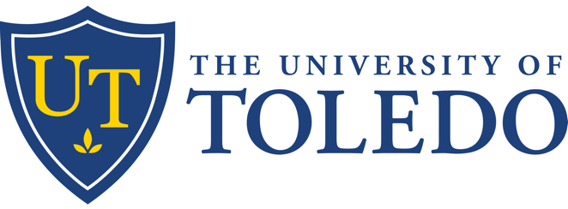

Transplant Healthcare Symposium- Living Donor Day

April 10, 2026 7:30 AM

Live Activity

Glass City Center-Downtown Toledo

Description

Welcome to the Transplant Symposium, offering a dynamic program for healthcare professionals, community members, and students interested in transplantation medicine. This course covers crucial topics such as protecting living donors, advancements in kidney disease prevention and detection, and innovations in transplant procedures. Through expert-led lectures, case studies, and interactive discussions, participants will gain valuable insights into the latest developments and best practices in the field of organ transplantation. Whether you're a healthcare provider, a student, or a community member, this symposium will broaden your understanding and inspire further engagement in transplantation care and research.

Learning Objectives

1 Apply evidence-based approaches to multidisciplinary collaboration in transplant medicine.

2 Describe current best practices in evaluating and caring for living organ donors across the transplant continuum.

3 Identify key clinical, ethical, and psychosocial considerations that impact donor and recipient outcomes.

Accreditation

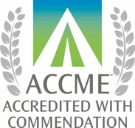
The University of Toledo is accredited by the Accreditation Council for Continuing Medical Education (ACCME) to provide continuing medical education for physicians.

Credit Designation

The University of Toledo designates this activity for a maximum of 6.00 AMA PRA Category 1 Credit(s)™.

Faculty & Planners

Name of individual | Individual's role in activity | Nature of Relationship(s) / Name of Ineligible Company(s)
Jennifer Archer, Other | Other Planning Committee Member
Obi Ekwenna, MD | Course Director

Commercial Support

This activity has been developed without commercial support.

