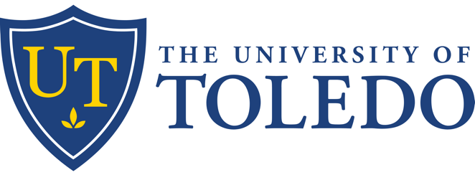

**Medical Education Grand Rounds**

**Crafting an Active Learning Pharmacology Curriculum: Dynamic Design**

November 15, 2024 12:00 PM

Enduring Material,Live Activity

University of Toledo Medical Center - Health Science Campus

**Specialties**

All Specialties

**Description**

Grand Rounds is a monthly sessions for faculty and staff to present their expertise and knowledge

**Learning Objectives**

1 Identify current trends and problems in education to help faculty become more effective

2 Develop and teach how to practice techniques for stress management.

3 Enhance faculty expertise of formative and sumrnative assessments.

4 Describe the master adaptive learner (MAL) conceptual framework and its relationship to professional identity.

5 Describe how the MAL framework supports the development of adaptive expertise.

6 Describe how educational activities across the UME educational continuum can be designed to support a MAL framework.

**Accreditation**

The University of Toledo is accredited by the Accreditation Council for Continuing Medical Education (ACCME) to provide continuing medical education for physicians.

**Credit Designation**

The University of Toledo designates this activity for a maximum of 1.00 *AMA PRA Category 1 Credit(s)*™.

**Faculty & Planners**

|  |  |  |
| --- | --- | --- |
| **Name of individual** | **Individual's role in activity** | **Nature of Relationship(s) / Name of Ineligible Company(s)** |
| Sandeep Bansal, MD, MBA | Faculty | Nothing to disclose - 09/30/2024 |

**Commercial Support**

This activity has been developed without commercial support.